**Bird Species Observation Analysis**

**1. Project Overview**

**Objective**

To analyze bird species observations across **forest and grassland ecosystems** to understand patterns in species diversity, temporal trends, and environmental influences. The goal is to generate actionable insights for biodiversity conservation and habitat management.

**2. Dataset Summary**

* Total Records: **17,077**
* Habitat Types: **Forest**, **Grassland**
* Year of Observation: **2018**
* Total Unique Species: **127**
* Source Files: Multi-sheet Excel files (Forest and Grassland parks)

**3. Methodology**

1. **Data Cleaning**:
   * Loaded and merged all Excel sheets from forest and grassland datasets.
   * Cleaned and standardized key columns (e.g., Date, Temperature, Humidity, Sky, Sex).
2. **Exploratory Data Analysis (EDA)**:
   * Conducted visual analysis of observation trends by time, location, species, and environmental factors.
3. **Environmental & Conservation Focus**:
   * Assessed how temperature, humidity, disturbance, and conservation status affect bird activity.

**4. Exploratory Data Analysis**

**4.1 Temporal Trends**

🟦 **[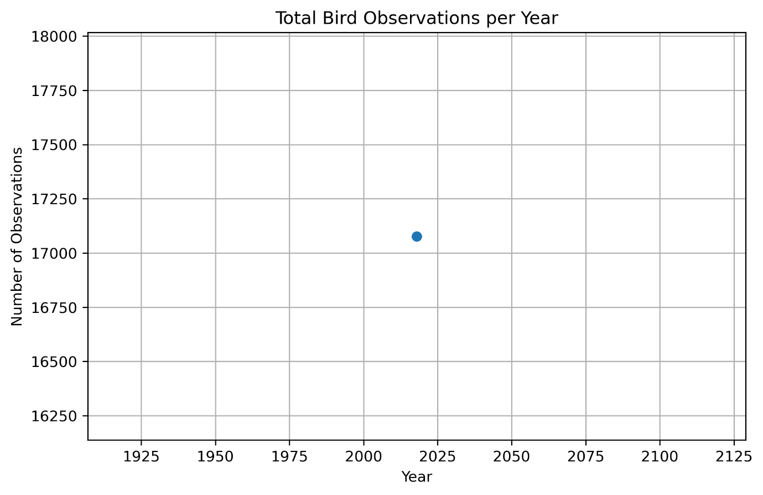]**

**[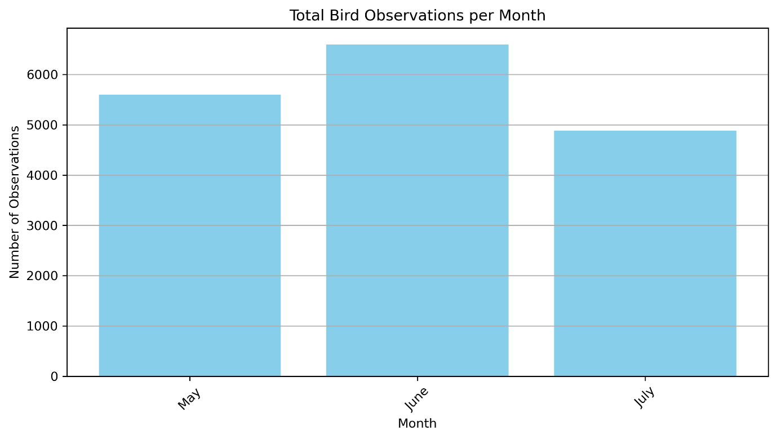]**

**Interpretation:**

* Observations are from **2018** only.
* **May and June** showed peak bird activity, indicating likely breeding/migration periods.
* July showed a decline in activity, potentially due to weather or reduced survey effort.

**4.2 Spatial Trends**

🟩 **[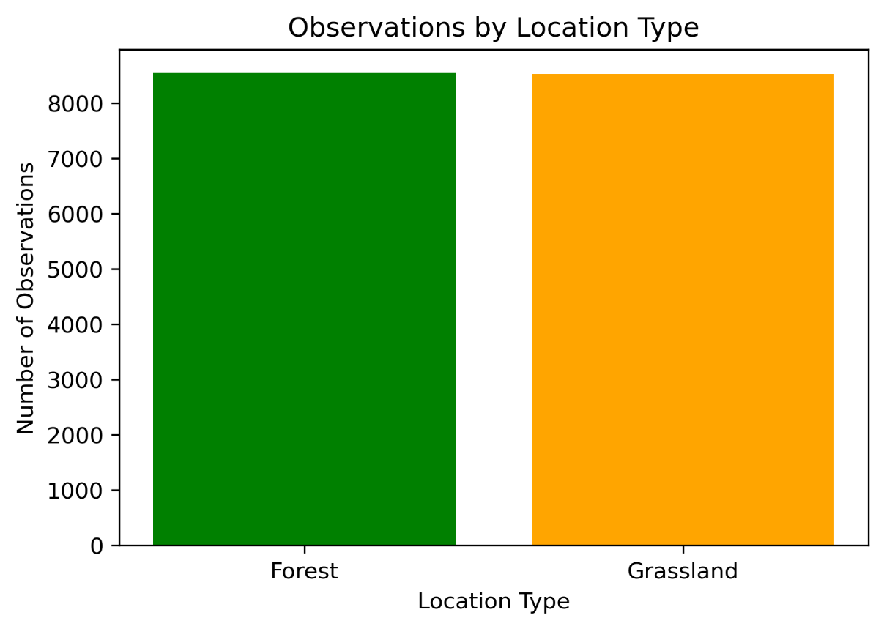]**  
**Interpretation:** Forest and Grassland recorded nearly **equal numbers of observations**, suggesting both are vital for biodiversity monitoring.

🟫 **[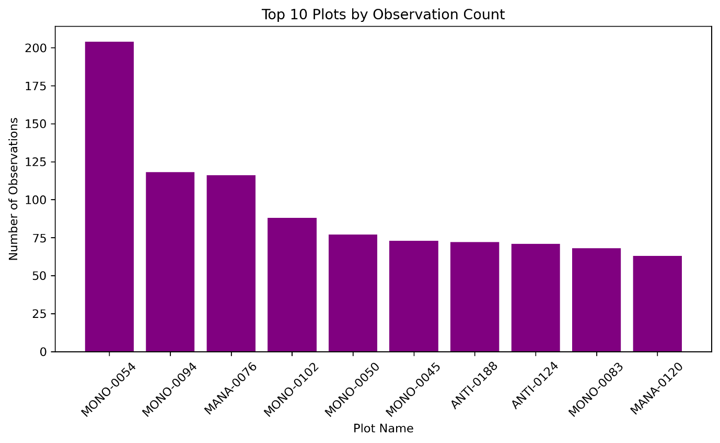]**  
**Interpretation:**

* **MONO-0054** had the highest observation count.
* Plots with consistently high activity could be biodiversity hotspots and deserve regular monitoring.

**4.3 Species Trends**

🟨 **Total Unique Species: 127**

🟨 **[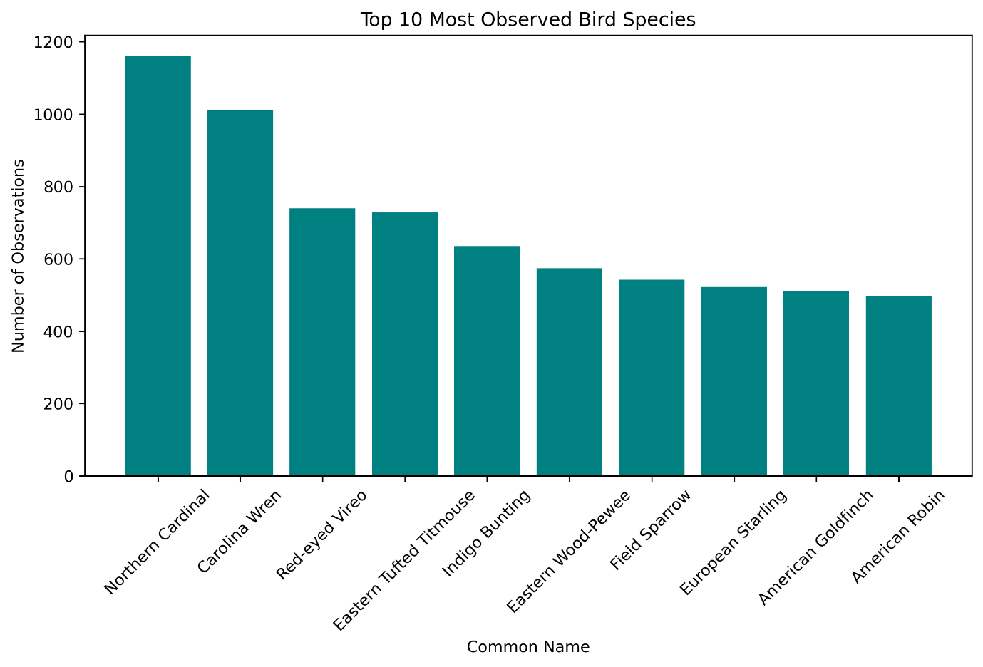]**  
**Interpretation:**

* **Northern Cardinal** and **Carolina Wren** were the most frequently observed.
* Some species are abundant and widely distributed, while rarer species may need focused attention.

**5. Environmental & Conservation Insights**

**5.1 Temperature vs Bird Count**

📊 **[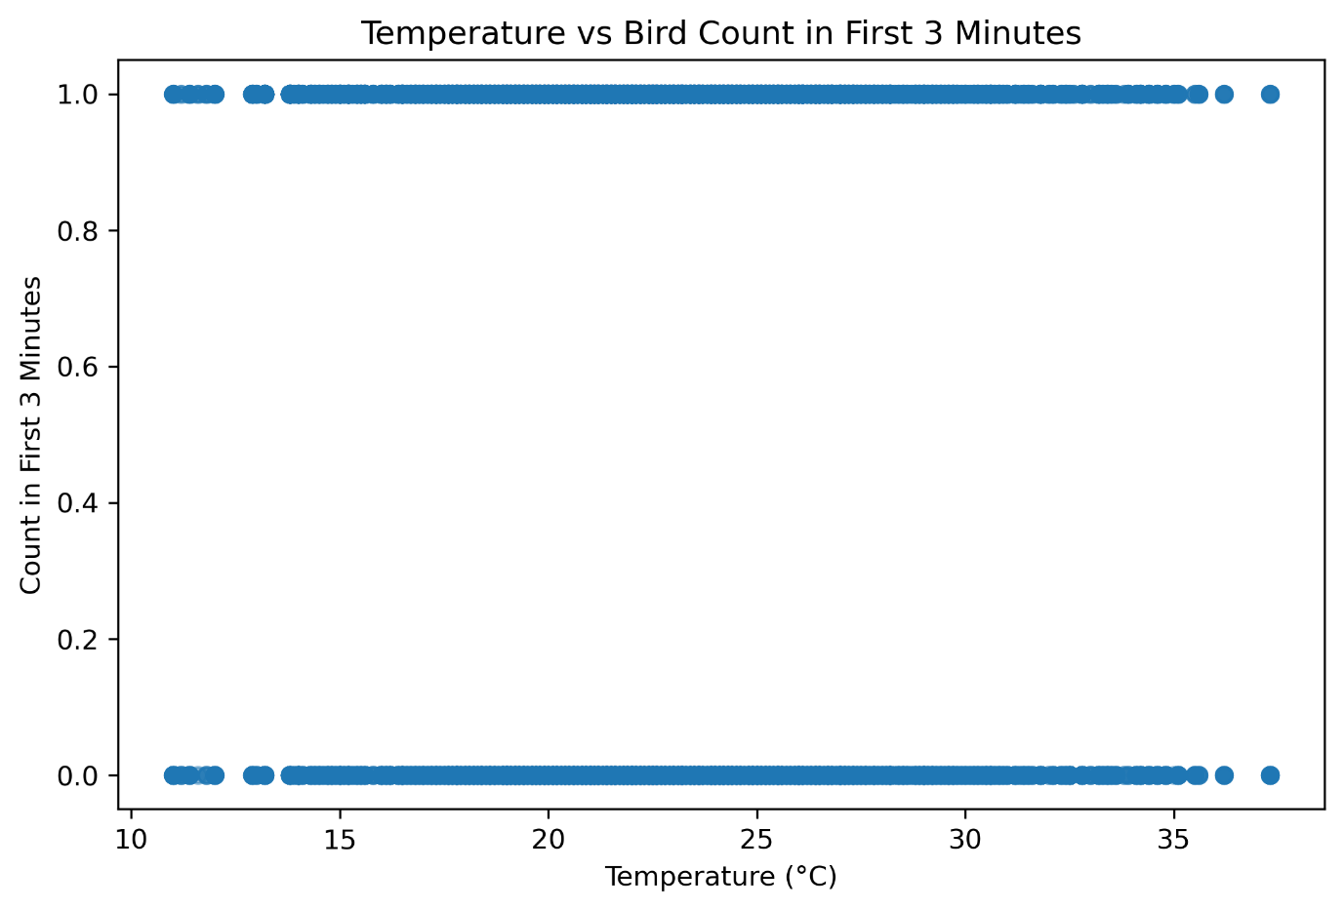]**  
**Insight:**

* Peak bird activity at **10–15°C**; activity drops after **35°C**.
* **Recommendation:** Schedule surveys during moderate temperatures (10–25°C).

**5.2 Humidity vs Bird Count**

📊 **[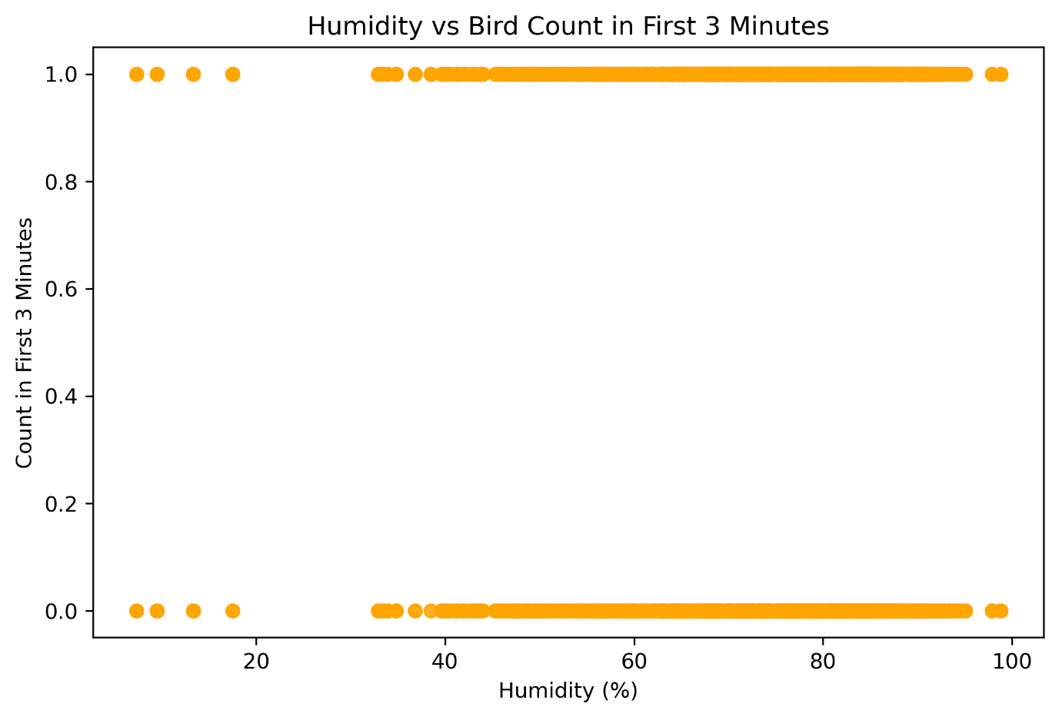]**  
**Insight:**

* Activity is high at **low (<40%)** and **high (>70%)** humidity.
* **Recommendation:** Early morning or humid conditions may yield better bird detections.

**5.3 Watchlist Status**

📊 **[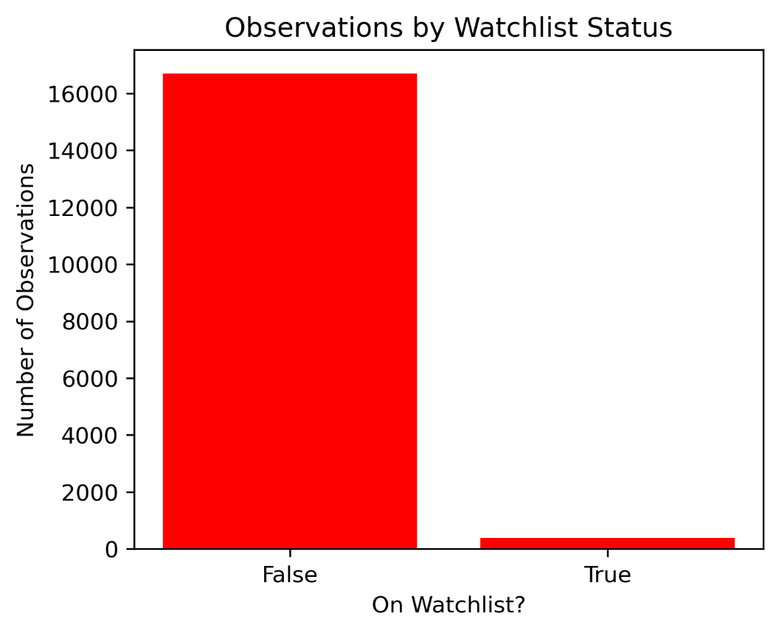]**  
**Insight:**

* **2.2%** of all observations are at-risk species.
* **Recommendation:** Continue monitoring these habitats; they support vulnerable bird species.

**5.4 Disturbance Impact**

📊 **[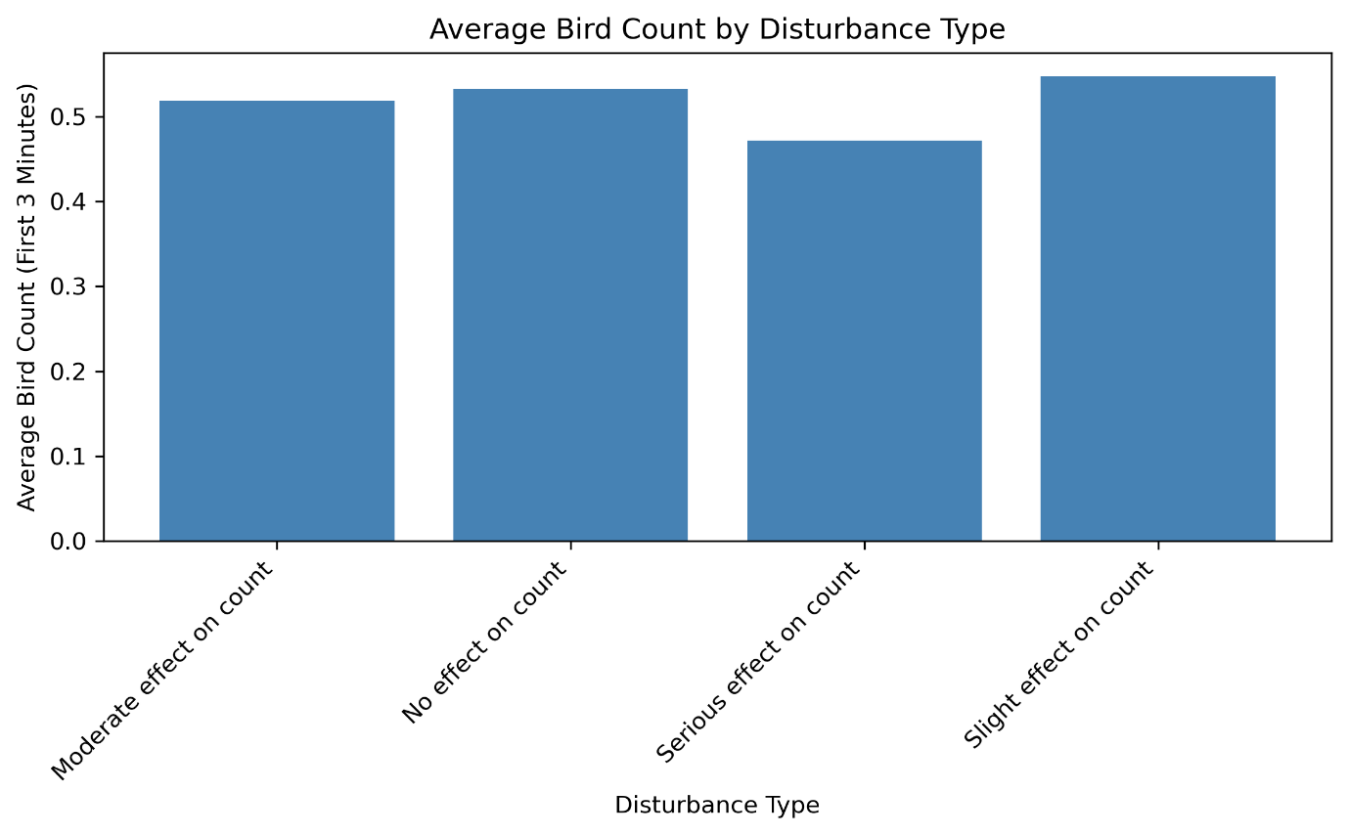]**  
**Insight:**

* Bird counts decrease with **serious disturbance**.
* **Recommendation:** Limit human interference near high-activity plots.

**6. Conclusion**

* Both **forest and grassland ecosystems** support a rich variety of bird species.
* The most productive observation periods were **late spring to early summer**.
* Environmental factors like **temperature, humidity, and disturbance** significantly influence bird activity.
* The presence of **watchlist species** makes these habitats critical for conservation.